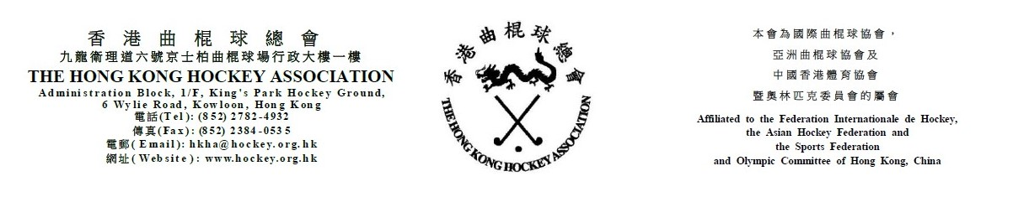

The Hong Kong Hockey Association

Extraordinary General Meeting on 20 July 2023

ATTENDANCE FORM
(Please see notes below before completing the form)
The following are authorized to represent __________________________________ (Club name) at the HKHA Extraordinary General Meeting on 20 July 2023:

Authorized to Vote
(tick one box only)
1. _____________________________________ ( )
(Name)
2. _____________________________________ ( )
(Name)
3. _____________________________________ ( )
(Name)

(Name of Club Official) |  | (Signature of Club Official)

(Position of Club Official) |  | (Date)

Notes: (1) Up to three persons can be authorized to attend the meeting. However, only one can be authorized to vote.
- Club officials include President, Chairman, Hon. Secretary, Convenor and Hockey Section Captain.
- This form must be received by the HKHA office no later than 5:00 p.m. on Thursday, 13 July 2023.

